**GAME DESIGN DOCUMENT**

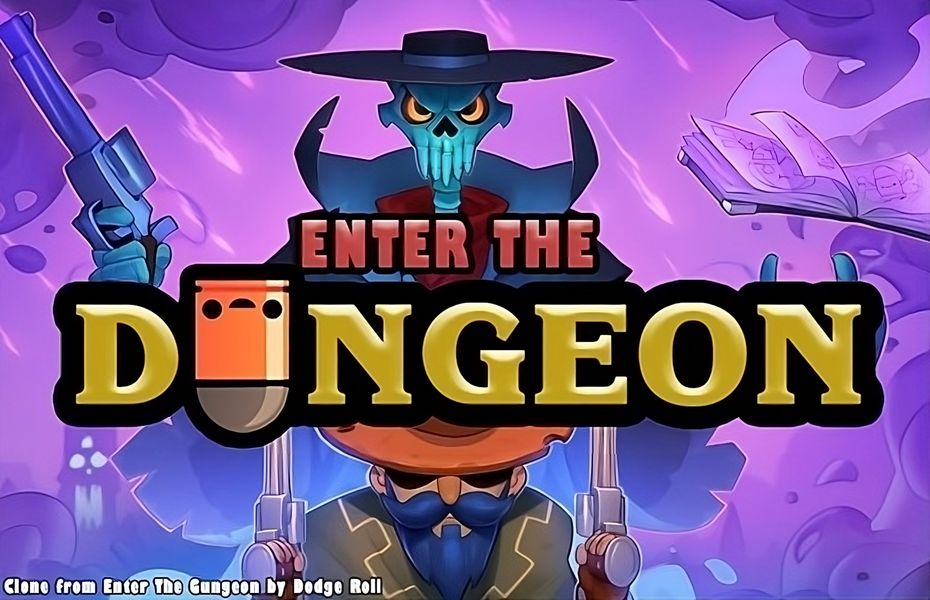

ENTER THE DUNGEON

**Last Updated:**

16/05/2023

**Prepared By:**

Ha Sy Tan Phat

**TABLE OF CONTENTS**

Game Analysis 3

Mission Statement 4

Genre 4

Platforms 4

Target Audience 4

Art Style 4

Storyline & Narrative 4

Core Gameplay 6

Overview 6

Main Character 6

Weapons and Items 6

Enemies and AI 9

Core Loop 13

Game Flow 14

Level Design 15

Design Pattern System 15

Control Scheme 20

Game Aesthetics & User Interface 21

HUD 21

Menus 22

Art and Visuals 23

Art Direction 23

Character Design 24

Map Design 24

# Game Analysis

Enter the Dungeon is an exhilarating fusion of roguelike dungeon crawling and twin-stick shooting that promises endless excitement and strategic depth. Set in a dark and immersive pixel-art world, players embark on a perilous journey into procedurally generated dungeons to retrieve ancient artifacts and vanquish powerful foes. The core loop revolves around exploration, intense real-time combat, and permanent character progression through relics and upgrades. What sets this game apart is its seamless blend of challenging gameplay, rich storytelling, and the ever-present thrill of risk and reward. As players conquer hordes of monsters, solve puzzles, and face formidable bosses, they'll uncover the game's captivating narrative, driving them to push further into the treacherous depths. Enter the Dungeon offers a relentless test of skill and strategy, ensuring that each playthrough feels unique and satisfying, making it an irresistible adventure for seasoned gamers and newcomers alike.

# Mission Statement

Enter the Dungeon is a pulse-pounding roguelike dungeon crawler, available on PC and consoles, where you become a hero facing relentless hordes of monsters, cunning traps, and epic bosses to reclaim ancient artifacts and restore light to a world shrouded in darkness.

# Genre

Genre: Roguelike Dungeon Crawler.

Perspective: Top-down.

Gameplay Style: Twin-stick shooter.

# Platforms

The game will be initially developed for PC.

# Target Audience

Enter the Dungeon is designed for gamers aged 16 and above who enjoy challenging gameplay, procedurally generated content, and a mix of strategy and action.

# Art Style

The game will feature a visually striking, pixel-art style with a dark and moody atmosphere, emphasizing the ominous feeling of exploring ancient, treacherous dungeons.

# Storyline & Narrative

1,147 years prior to the Hunter's adventure into the Gungeon, she travelled to Blacksword Manor to defeat Dr. Wolfenclaw; however, she was captured and stored in a Cryo Pod until the events of Enter The Gungeon. It is unknown how she escaped the Cryo Pod.

***Past Kill***

If the Bullet That Can Kill The Past is used on The Hunter, she will be brought back to the front entrance of Blacksword Manor before her capture. After entering the manor the Hunter will eventually come across a strange machine. Dr. Wolfenclaw will appear and greet the Hunter, saying that he's thrilled to be able to use her in his latest experiment. The Hunter responds by saying that she will not let him have his way with her and that she's come to stop him and his twisted religion. Dr. Wolfenclaw will then summon a circle of bullets, trapping The Hunter. The player will be given the option to use a Blank to destroy the trap. Dr. Wolfenclaw will initially be surprised by such advanced technology, but claims that it won't matter and decides to unleash his monster upon The Hunter. Should The Hunter defeat the monster, she will be relieved that it is finally over and leave the manor with Junior.

In her search for the kill the past, she has gone through many dungeons with different types of environmental cultures, each influenced by the events of Enter The Gungeon. It was an event cursed by Bullet That Can Kill The Past that made all the creatures living in these dungeons gradually become a form of bullet.

# Core Gameplay

## Overview

The core gameplay is moment-by-moment action in the game, mainly movement and shooting mechanics. They are primarily about the ability to master the individual and defeat the enemy.

Key gameplay features include dynamic twin-stick combat, permanent character progression through relics, challenging boss battles, atmospheric pixel-art visuals, and a compelling narrative. Enter the Dungeon offers a captivating solo adventure that challenges players to explore the depths of treacherous dungeons, delivering an unforgettable experience that combines the best elements of multiple genres.

## Main Character

|  |  |  |  |
| --- | --- | --- | --- |
| Character | Description | Characteristics | Misc. Info |
| The Hunter | The Hunter is one of the Gungeoneers in the game Enter the Gungeon. The Hunter is equipped with the Rusty Sidearm, Crossbow, and Dog. | The Hunter is a resilient and agile Gungeoneer, making her mark in the Gungeon with her resourcefulness. Armed with a Rusty Sidearm and a potent Crossbow, she excels in precision combat. | Non. |

## Weapons and Items

* Weapons

|  |  |  |
| --- | --- | --- |
| Weapons | illustration | Description |
| Rust Sidearm |  | Starting gun of The Hunter. |
| Crossbow |  | The Crossbow is a gun that fires a single high-damage bolt. The Hunter starts with this gun. |
| AK-47 |  | Rifle with high speed and powerful damage. |
| Blasphemy |  | Starting weapon of The Bullet. Swings destroy nearby bullets. At full health, swings send out a piercing sword projectile. |
| BubbleGun |  | Fires bubbles which move slowly towards enemies. Reloading the gun launches bubbles away from the player at high speed. |
| CactusGun |  | Fires needles. |
| CrystalGun & CrystalGun2 |  | Fires laser shots at enemies. The last bullet of magazine fires a crystal, which splits into 5 small crystals on impact |
| ElectricRifle |  | Fires a zap of electricity. |
| FossilizedGun |  | Fires a stream of oil. Reloading spits fire, which can ignite the oil. |
| Magnum |  | 5 Shots Or 6? |
| Phoenix |  | Shooting creates a small cone of fire in front of the player that burns enemies. |
| Shotgun |  | Large damage but small range. |
| ShotgunSawOff |  | Large damage but small range. |
| Siren |  | Fires a shotgun blast of bullets that leave pools of water. Negates fall damage and goop effects while equipped. |
| SuperSoaker |  | Fires a stream of water. |
| TommyGun |  | Shoot fast! |
| Trident |  | Fires a long-range laser that pierces one enemy. Destroys nearby bullets and pushes enemies away while reloading. |

* Items

|  |  |  |
| --- | --- | --- |
| Items | illustration | Description |
| Hegemony Credits |  | Standard currency throughout Hegemony of Man controlled systems, can be found upon finishing the tutorial, defeating bosses, etc. Can be used to purchase items in The Breach that will show up in future runs. |
| Shells |  | Shells (also referred to as casings or coins) are the game's main form of currency, and are often dropped by enemies upon their death. They can be used to purchase items in Shops and make wagers with various NPCs. |
| Ammo |  | Ammo is required for the player to use their weapons. The player can collect ammunition from defeated enemies, find it in treasure chests, or purchase it from vendors. |
| Keys |  | Keys are required to open locked doors and chests found throughout the levels. The player can collect keys from defeated enemies or purchase them from vendors. |
| Health |  | The player has a health bar, which decreases when the player takes damage from enemies or hazards. The player can collect health items, such as hearts and health kits, to restore their health. |
| Blanks |  | Blanks are special items that the player can use to create a shock wave that will clear all the bullet that them from enemy bullets for a short period of time. Blanks are special items that the player can use to create a shock wave that will clear all the bullets that shoot from enemy and prevent them shooting for a short time. |
| Armor |  | Armor is appended to the end of the player's health bar upon pickup, and the player can carry multiple pieces of armor. Armor absorbs one hit, after which it is destroyed. Whenever armor is destroyed, a Blank is activated for free. |

## Enemies and AI

• Enemies

|  |  |  |
| --- | --- | --- |
| Enemies | illustration | Description |
| Bullet Kin |  | Slowly walks towards the player, firing bullets. |
| Blue Shotgun Kin |  | Slowly walks towards the player, occasionally firing a wide spread of 5 bullets quickly followed by a wide spread of 4 bullets. |
| Red Shotgun Kin |  | Slowly walks towards the player, occasionally firing a tight spread of 5 bullets. |
| Bandana Bullet Kin |  | Slowly walks towards the player, rapidly firing bullets. |
| Blue Bookllet |  | Occasionally fires bullets towards the player in circle patterns with various radio. |
| Hollowpoint |  | Floats towards the player, rapidly firing bullets. |
| King Bullat |  | Periodically fires bouncing bullets in all directions. |
| Gigi |  | Occasionally fires bullets towards the player in circle patterns. |
| Muzzle Wisp |  | Occasionally fires bullets towards the player in circle patterns. |
| Cubulon |  | Occasionally fires bullets towards the player in circle patterns. |
| Bullat |  | Launches itself at the player |

• Bosses

|  |  |  |
| --- | --- | --- |
| Bosses | illustration | Description |
| Blobulord |  | Blobulord is a boss found in the chamber 1. |
| Gatling Gull |  | Gatling Gull is a boss found in the chamber 2. |
| Lich |  | Gatling Gull is a boss found in the last chamber. |

• Enemy movement

In this project, we use NavMeshPlus made by h8man in github, NavMesh building components provide ability to create navigation meshes that are generated automatically from your Scene geometry, which allows characters to move intelligently around the game world.

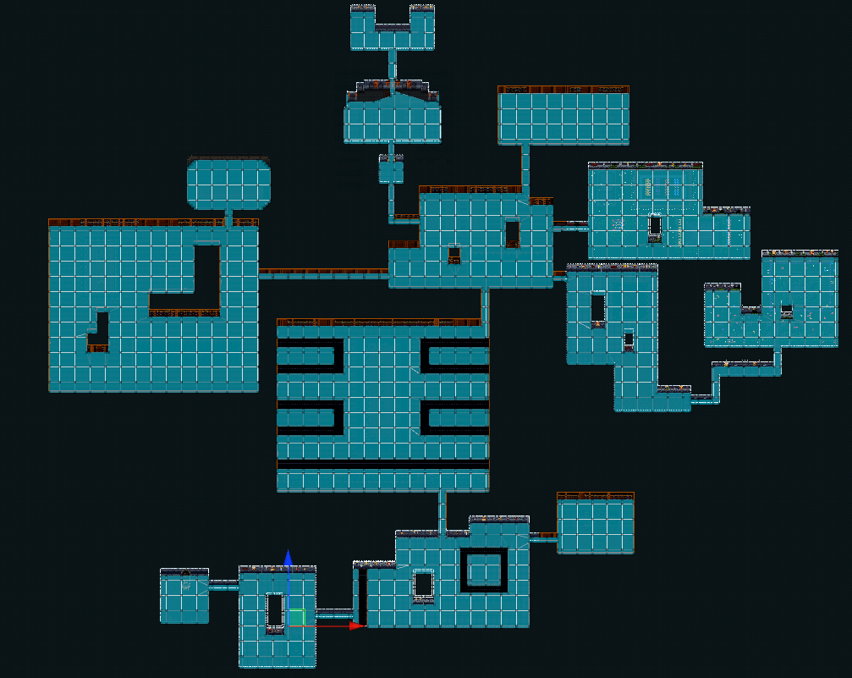

## Core Loop

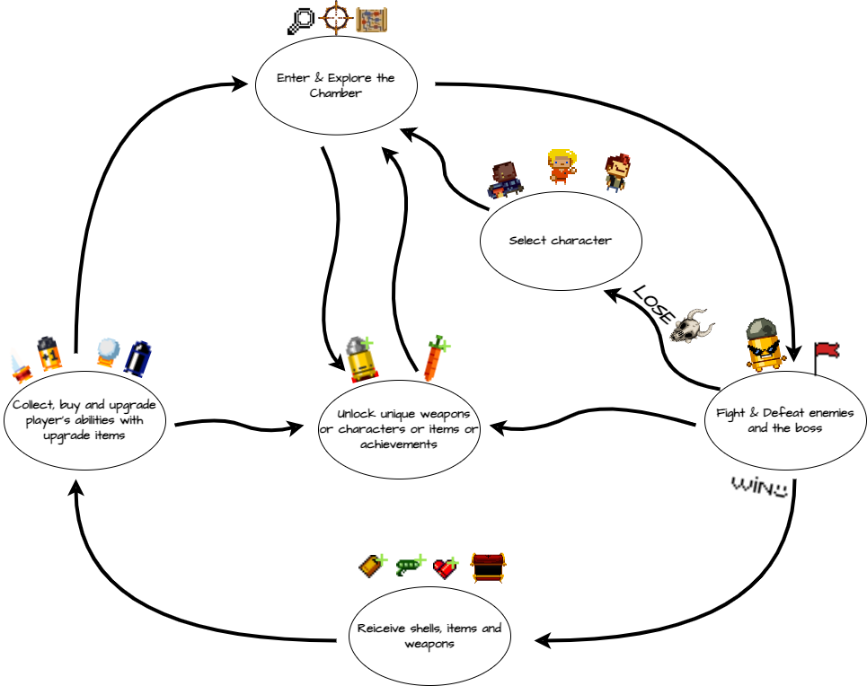

## Game Flow

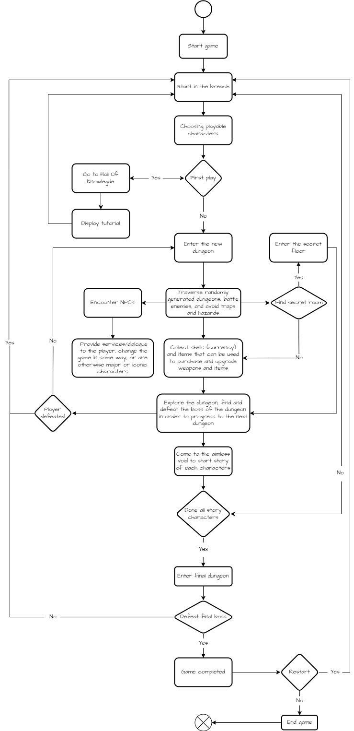

## Level Design

.

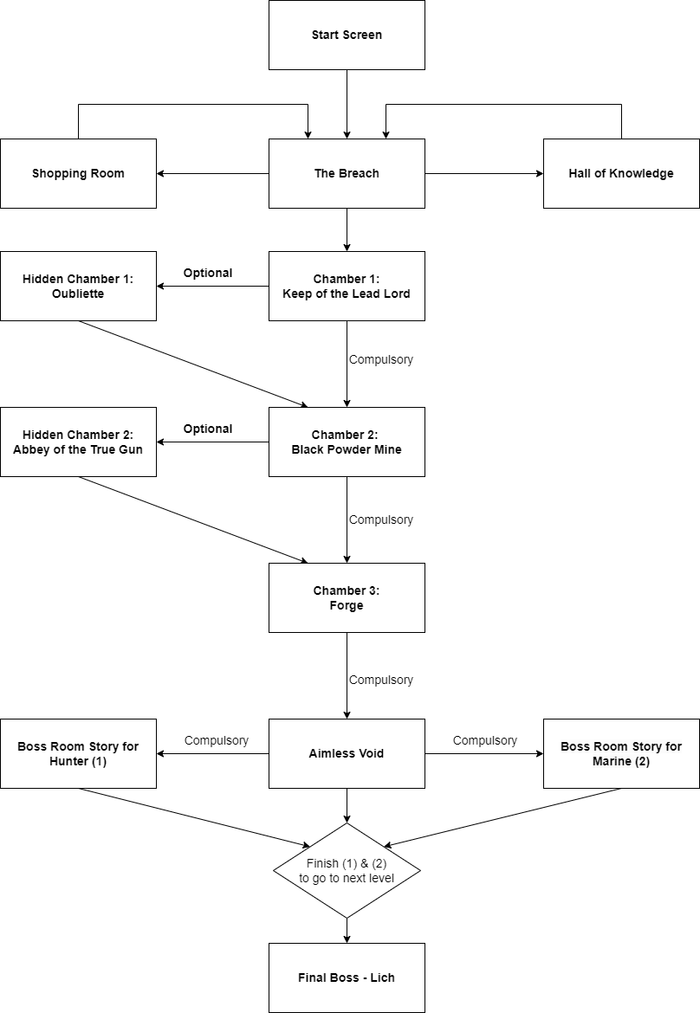

## Design Pattern System

* State Pattern

State is a behavioral design pattern that lets an object alter its behavior when its internal state changes. It appears as if the object changed its class. In this project, We use to manage the states of characters, enemies, etc.

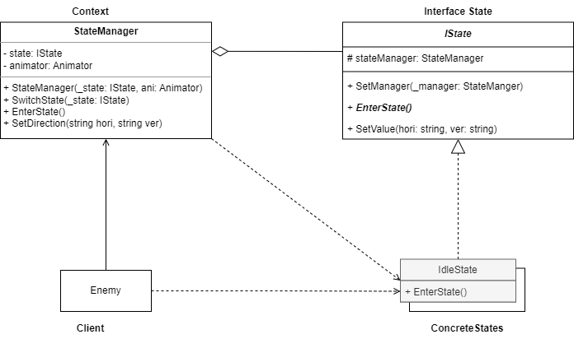

* Command Pattern

For Input Controller, command is a behavioral design pattern that turns a request into a stand-alone object that contains all information about the request. This transformation lets you pass requests as a method arguments, delay or queue a request’s execution, and support undoable operations. In this project, we use to handle key press events for special features.

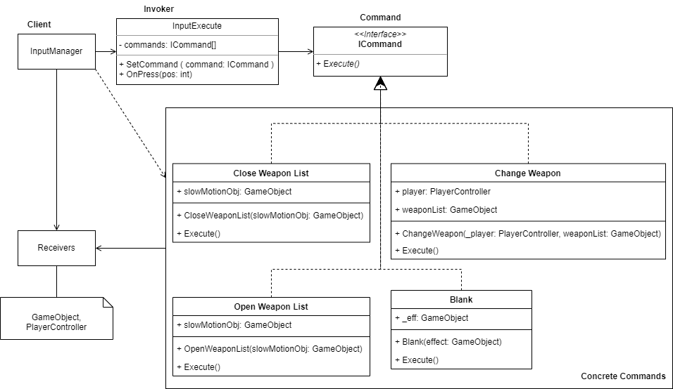

* Singleton Pattern

Singleton is a Design Pattern that ensures each class has only one instance, and provides a global access point for this instance (Controllers, Player, UI, sound, etc) for game controller.

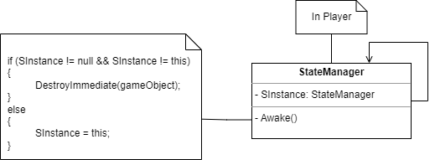

* Object Pool Pattern

Object Pooling is a great way to optimize your projects and lower the burden that is placed on the CPU when having to rapidly create and destroy GameObjects. It is a good practice and design pattern to keep in mind to help relieve the processing power of the CPU to handle more important tasks and not become inundated by repetitive create and destroy calls.

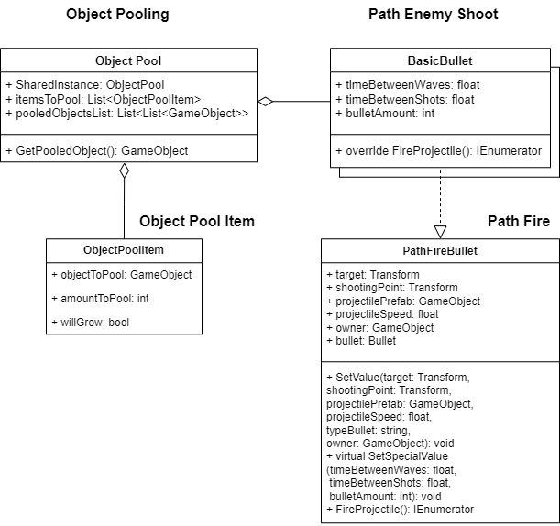

* Observer Pattern

Observer is a behavioral design pattern that lets you define a subscription mechanism to notify multiple objects about any events that happen to the object they’re observing. In this project, we use to update UI when player's health or other parameters change.

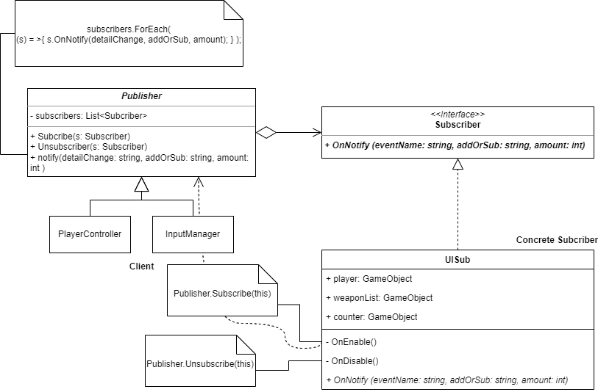

* Strategy Pattern

Define a family of algorithms, encapsulate each one, and make them interchangeable. Strategy lets the algorithm vary independently from the clients that use it. In this project, we use this pattern to define the path fire bullets.

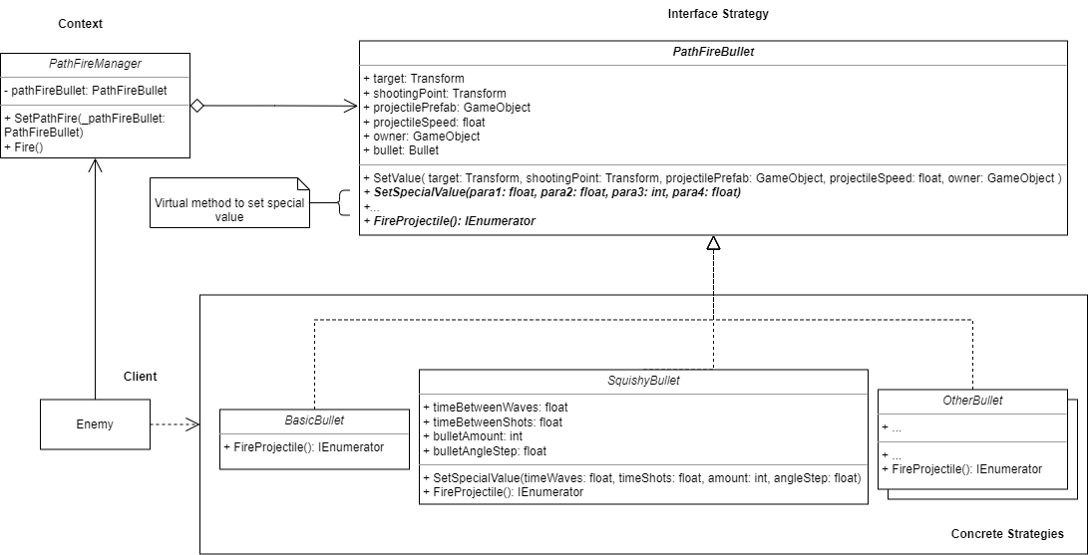

* Template Pattern

Template Method is a behavioral design pattern that defines the skeleton of an algorithm in the superclass but lets subclasses override specific steps of the algorithm without changing its structure. In this project, we use to define to choose the skills for boss.

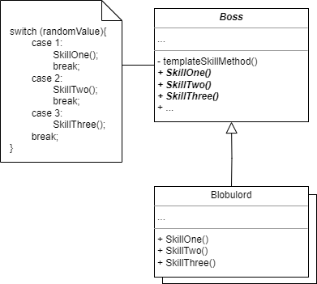

# Control Scheme

|  |  |
| --- | --- |
| **Button/ Touch Input** | **Action it Performs** |
| Shoot | Left Click |
| Dodge | Right Click |
| Interact | E |
| Reload | R |
| Move Up | W |
| Move Down | S |
| Move Left | A |
| Move Right | D |
| Use Blank | Q |
| Next Weapon | Scroll Wheel Up |
| Previous Weapon | Scroll Wheel Down |
| Slow Time | Left CTRL |
| Pause | ESC |

# Game Aesthetics & User Interface

## HUD

* The Breach

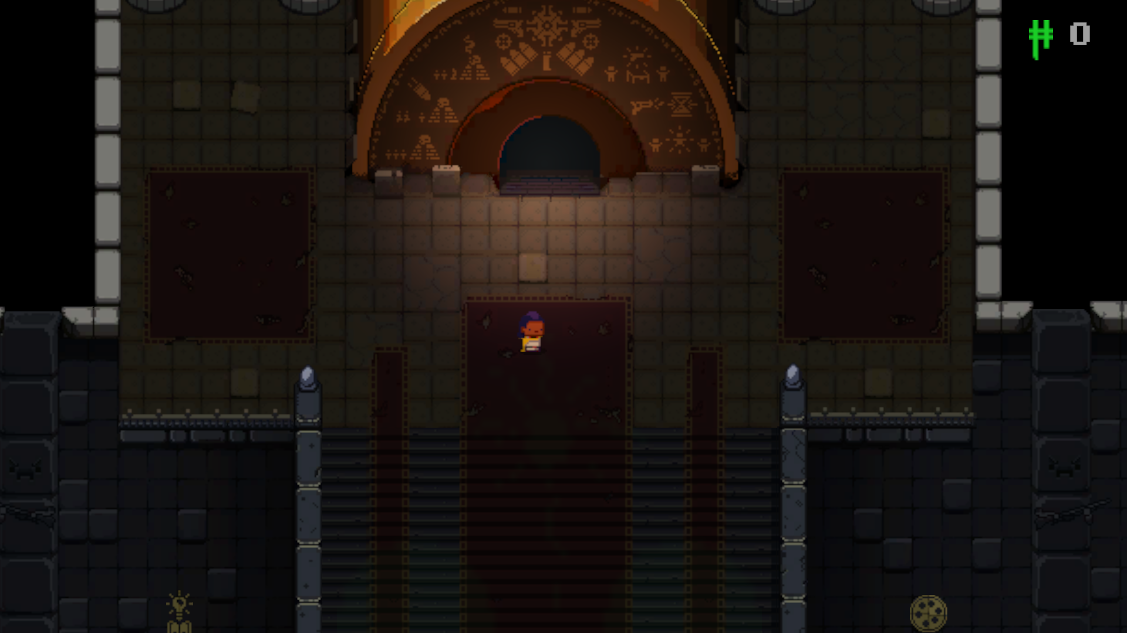

* Dungeon

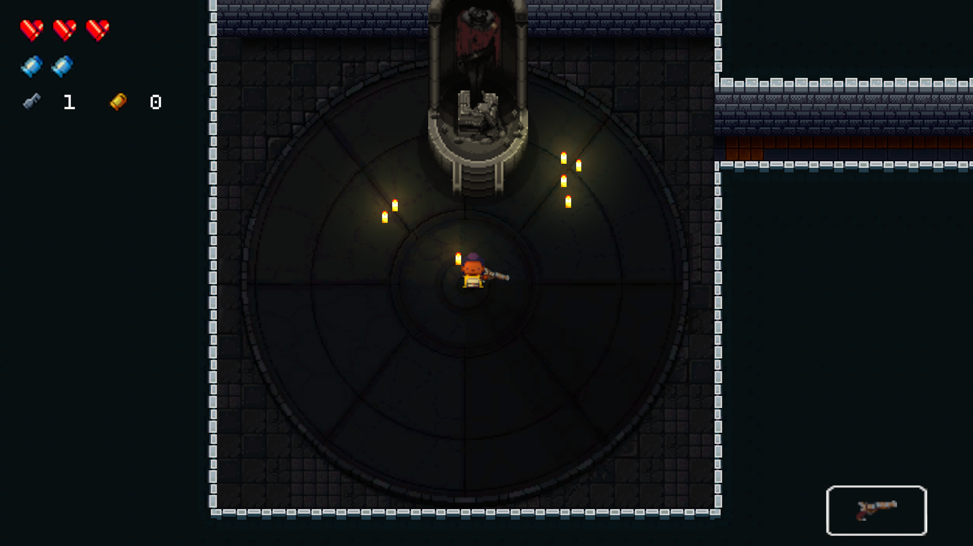

## Menus

* Main Menu

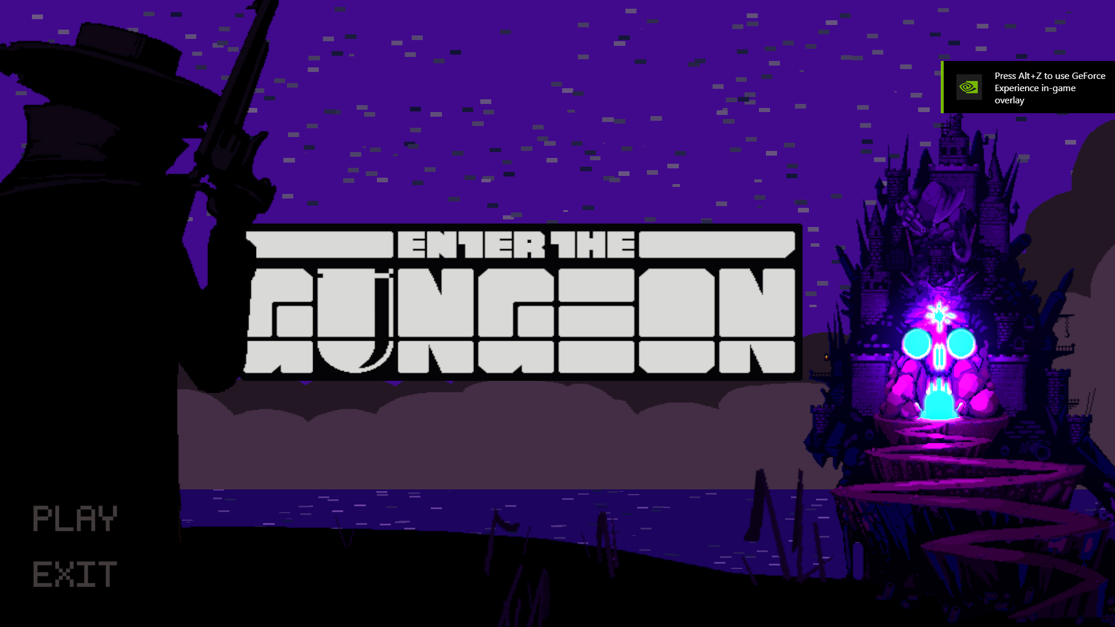

* Pause Menu

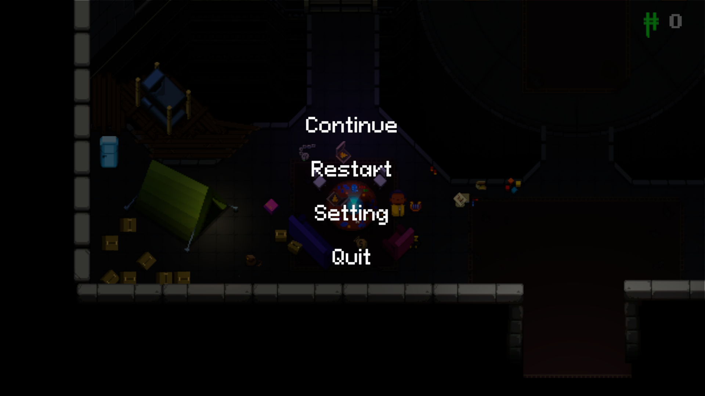

* Setting Menu

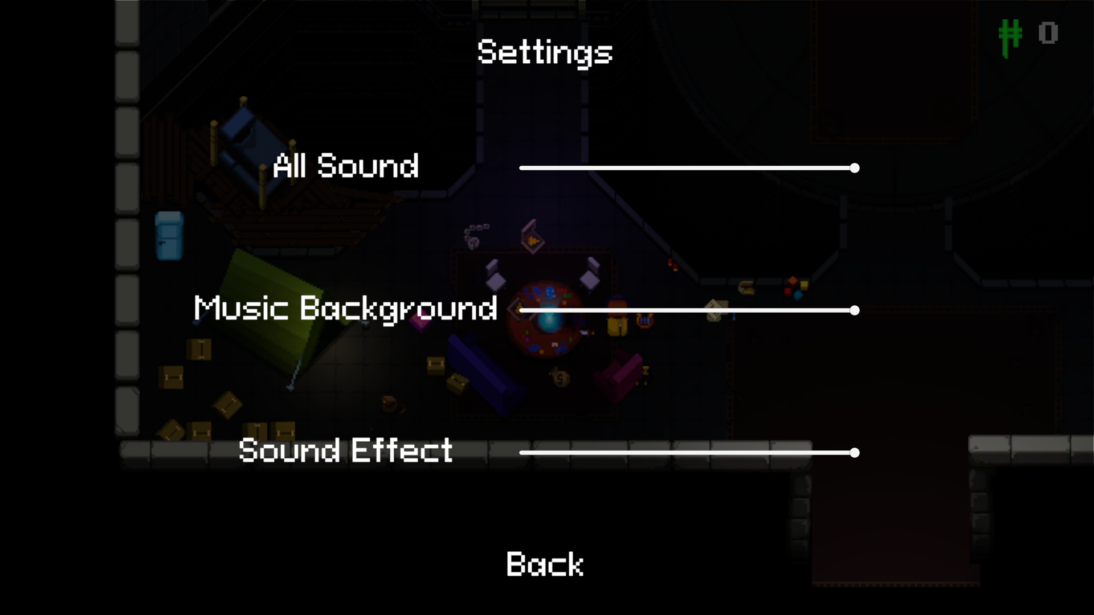

# Art and Visuals

## Art Direction

* Art Style: The game features a visually striking pixel art style that complements its dark and moody atmosphere, immersing players in a visually captivating world.
* Platform Adaptation: Designed for PC and consoles, the game optimizes controls for each platform, ensuring seamless gameplay. Potential adaptations for mobile and VR platforms are considered for future releases.
* Game Modes: Players play on a challenging single-player.
* Key Features: Twin-stick shooting mechanics, procedurally generated dungeons, permanent progression, epic boss battles, and a rich narrative create a unique and immersive gameplay experience.

## Character Design

* The Hunter

|  |  |  |  |  |  |
| --- | --- | --- | --- | --- | --- |
| **Front** | **Back** | **Left** | **Right** | **Back Left** | **Back right** |
|  |  |  |  |  |  |

## Map Design

* The Breach

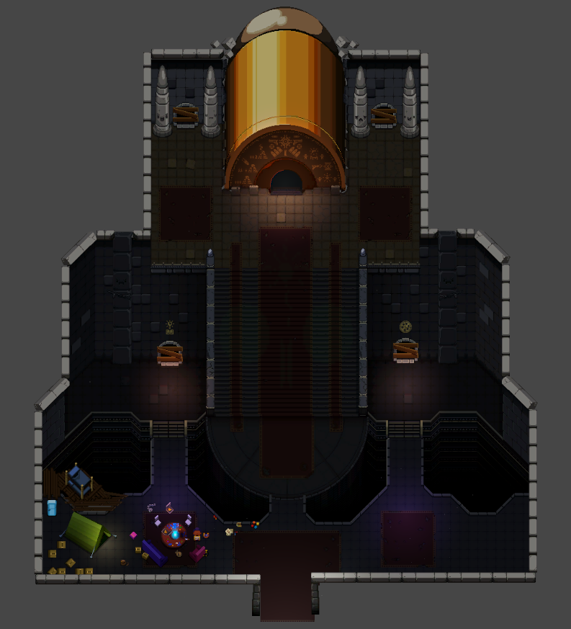

* Chamber 1

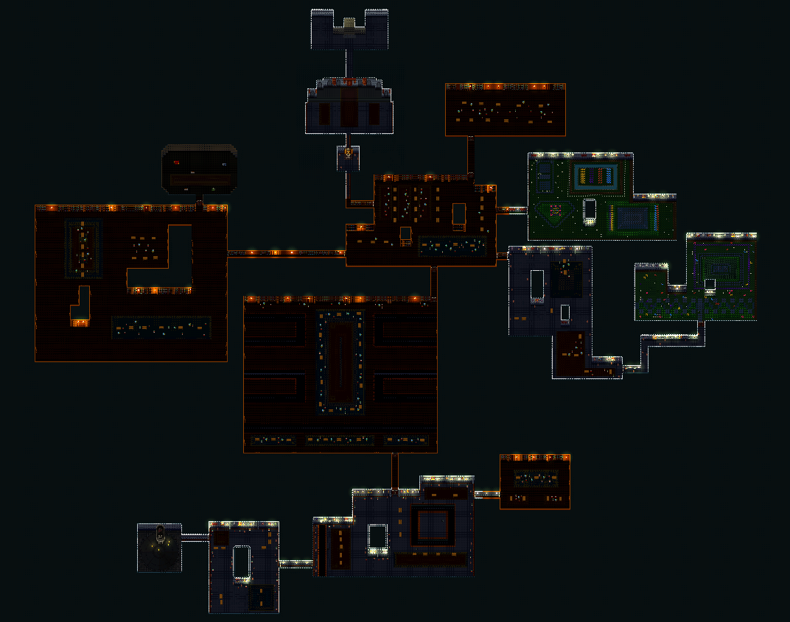

* Chamber 2

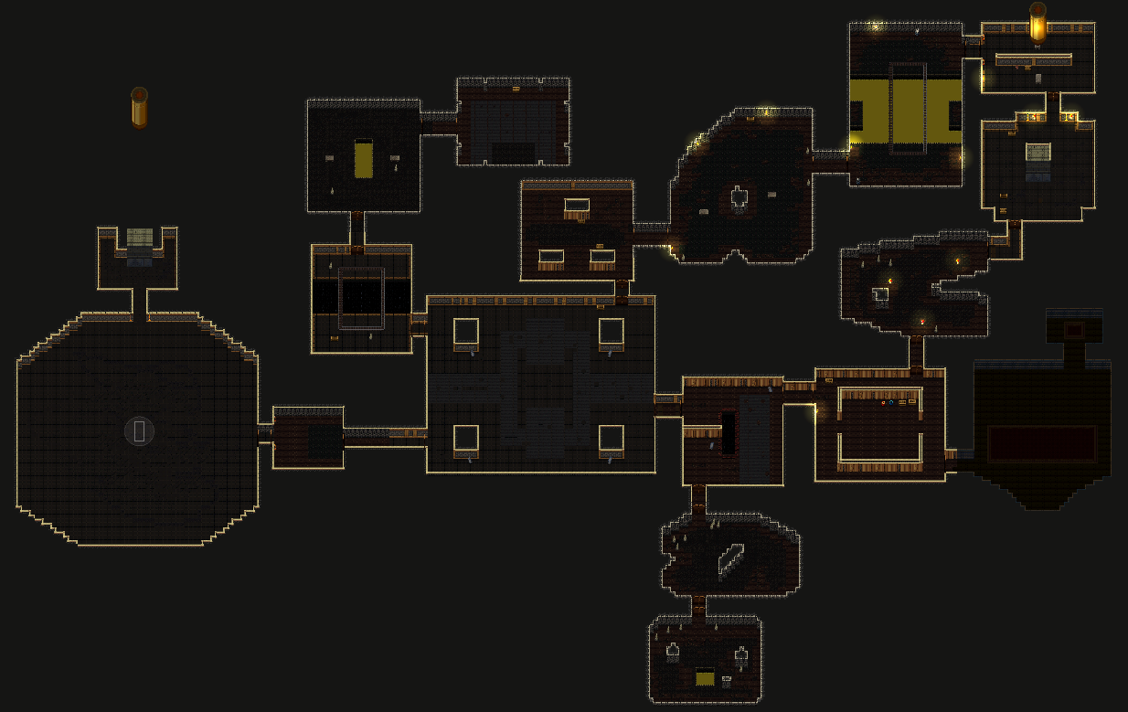

* Aimless Void (End Game)

